Antibarbari for dummies

Inhoudsopgave
Introduction 3
Competition preparations 4
2.a. Team Structure 4
2.b. Match Kits 4
2.c. Match Rules 4
2.d. Erasmus Sports Pass 5
Practice 5
3.a. Field scheme 6
3.b. Materials 6
3.c. Schaft 6
3.d. Cooking shifts and Cleaning shifts 7
Matches 7
4.a. Match registration 8
4.b. Away matches 8
4.c. Referees 8
4.d. Statistics 8
4.d.1. H.E.L.D 9
4.d.2. D.R.A.N.K 9
4.d.3. De Gouden Zaag 9
4.e. Match report 9
Responsibilities Captain 10
5.a. board 10
5.b. practices 10
5.c. matches 10
6. Activities 11
6.A. Calendar 11
6.B. Committees 11
6.B.1. Party Committee 12
6.b.2. Social Media Committee 12
6.b.3. Tournament Committee 12
6.b.4. Sponsoring Committee 12
6.b.5. ABB Open committee 12
6.b.6.Birthdaytrip committee 13
6.b.7. Antibarbaski committee 13
6.b.8.Eurekaweek committee 13
6.b.9. Technical Committee 13
6.b.10 Antiblablablad 13
6.b.11 Introductory weekend 13
6.B.12 First-year committee 13
6.B.13 Cooking Committee 14
6.B.14 Hand-in-hand commission 14
6.c. Board year 14
7. Antibarbari 15
7.a. Board 17
7.b. Contact person 19
7.c. Code of conduct 20

Introduction
We would like to welcome you at the student football association Antibarbari! This is the ‘Antibarbari for dummies’, here you can find all the ins and outs of our association. We set this up to make the first few weeks at Antibarbari more fun and easier as you will already know a lot after you have read this. Don’t forget that you can always come to us when we’re at Antibarbari or you can send us an email/WhatsApp or call me to ask all your questions! At the end of the document, you can find our contact details.
As a first year you’ll mostly be in contact with Vice-President Iris de Winter and Technical Commissioner Iris Mulder. For soccer related questions, such as materials, trainings, etc. you can contact Iris Mulder. For everything else, for example parties, committees, etc. you can contact Iris de Winter. Of course, the rest of the board is also available to you!

Competition preparations
Before the competition can start some things need to be arranged, in this section you can read all things that need to be done/known.

2.a. Team Structure
A team at Antibarbari consists of match players and players that only participate during practice. There will be around 25 match players within the team.
Players who only participate during practice are, normally spoken, not allowed to play any official matches. Those players are not registered at the KNVB (Dutch football association), this may lead to lots of problems if they will play a match. If there really is an emergency and the team does not have enough players, it is sometimes possible to let one of those players play but only after having discussed this with the secretary.

2.b. Match Kits
All match players, of course, need to have their kit before the start of the competition. The technical commissioner orders the kits. Before ordering the kits, the technical commissioner will get in touch with the team captain to get to know all the sizes, back numbers and names that the team needs. The costs of the kits will need to be paid by the players. This automatically means that the kit is your own possession. The costs are around 60 euros.
Some teams decided to order some spare kits, of course this is possible but remember that these costs also need to be paid by the team.
Goalkeepers need another kit than the regular player kit. This cost of this kit is also around 60 euros. The gloves are not included. The technical commissioner can order gloves as well, if you ask. These costs will again be for the team.
At the start of the season, it is quite busy for the supplier. Normally spoken, orders will be delivered within two weeks. Due to the busy days, it can be the case that the match kits will not be on time. If this is the case, the technical commissioner will get in touch with the captain and together they will look for a suitable solution.

2.c. Match Rules
The secretary will sign up all players before the start of the competition at the KNVB. Internationals, players who have never played football before and players born after 1998 need to make sure they have proven their understanding of the rules. This is a rule of the KNVB. Players who have (recently) played football most times already have this license. Players who still need to get their license will receive an email from the KNVB.
Unfortunately, the test is only available in Dutch. I would advise the team to see if other Dutch team members can do the test for the International team members. If this will lead to any difficulties don’t hesitate to contact the secretary!

2.d. Erasmus Sports Pass
The contribution of the competition membership includes an Erasmus sports pass. This pass can be picked up at Erasmus Sport as soon as the payment has been made and the treasurer/secretary has sent the batch of payments to Erasmus Sport. If you have chosen to pay in instalments, you don't have to wait until the first instalment is paid before you can start playing sports. Your name will simply be included in the first batch. The date on which you have chosen to pay in instalments in clubcollect is taken as the starting point.
The board will let the team know when which batch has been sent, so the tip is to pay the contribution as soon as possible to be able to collect your sports pass as soon as possible!
With the sports pass you can follow group lessons at Erasmus Sport and book courts. You can also use it to go to the gym for an additional fee.

Practice
All practices take place on Tuesday and Thursday evenings. At Antibarbari, all recreational teams train themselves. One of the players will prepare the practice material. You can also look for a coach if you, as a team, would like!

3.a. Field scheme
Antibarbari has got two fields available for practice, field 2 and Hermandad (HDAD). Normally spoken, your practice will take place on the same field on the same day. During the season 20/21 there is only one exception, that is Thursday 21:00. If your practice is at this time and day, the field your practice will take place on changes to make sure every team will have the chance to train on a bigger field. Below you will find an image of the sports park with the fields.
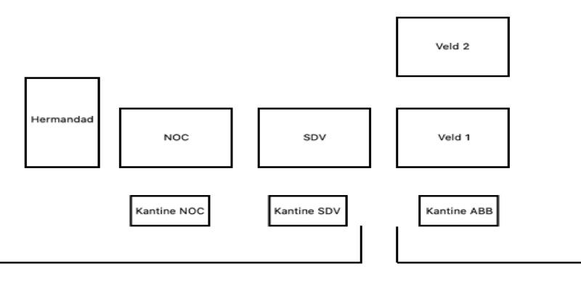

3.b. Materials
Every new team will receive 5 new balls, condes, dibs and a bag for the balls. Antibarbari often has a lot of dibs and cones, so If you need more you can always ask the technical commissioner.
5 Balls are not a lot, so watch them and treat them right! This means that if the ball will end in the ditch you will need to get it out. If you would like to have more balls, the technical commissioner can order them for you for 25 euros per ball.
Every team (new teams excepted) will receive 2 balls each season. As soon as these balls are delivered, the technical commissioner will send a message to the captains that they will be able to get them.
All teams can put away their materials in lockers. The technical commissioner will make sure you will receive a key and will show you the locker. On Tuesday, Thursday and Sunday you will be able to get your own materials as you will have the key. At the lockers it will also be possible to pump up the balls. Make sure to be careful with the locks.
Close to both fields, you will be able to find small goals. These goals may be used as long as they will be put back if no one will use them anymore. Of course, there are also bigger goals that may be used. Due to the fact that more teams have their practice on the same field, communication about the goals is important.

3.c. Schaft
Every Tuesday and Thursday evenings it is possible to schaft at Antibarbari! For only 4 euros you will get a meal including a desert! A lot of teams take this opportunity. There are always two shifts. The first shift is at 18:30 and the second shift at 19:30.
You can sign up for the dinner on the day itself via the site. A message is always posted with what will be cooked, below you can comment with your name, which shift and if you are vegetarian, this must also be mentioned. You can sign up on the day itself until 14:00! It is also possible to respond with a list of names. The platter is always cooked by freshmen and you will receive additional information about this from the vice-chairman.
It is possible to pay in cash or via iDeal. It is also possible to purchase a ticket. You pay twenty euros for a snack card and you can buy six times (so once for free)!
If you schaft with 8 players from your team, you can get a ‘schaftpitcher’ (beer pitcher) for free! You just need to mention this to one of the board members and you will be able to get the pitcher the same evening!

3.d. Cooking shifts and Cleaning shifts
In your first year, you are also required to run shifts to help keep the club running. These are first of all cooking services that we just briefly discussed, from 14:00-17:30 you will cook the meal with other freshmen. The purchases will be made in advance by the Vice-President. After this service you can eat for free and it is of course nice to stay at the club.
Cleaning services start at 12:00 PM and last until 3:00 PM. With these services you and other first-years will ensure that the building is in good condition again. There is always someone from the board to ensure that this is managed in the right direction and the board ensures that the right equipment is present.

Matches
On Sundays the matches are played. Every team has their own standard match time at Antibarbari.

4.a. Match registration
Before the match, you should know how many players will be there. It is possible to sign up (max) 16 players for the match. All players that will be there during the match need to be on the match form, an assistant referee needs to be filled out as well (often one of the substitutes). If you have more than 16 players available, the captain can ask other teams if they need players so everyone will be able to play a match.
The match form can still be filled out during the match, but it is advisable to fill it out before the start of the match. Do not fill it out too early, as you can only fill it out once and from then on only the secretary can make any changes. Only players that are 18+ can fill out the form. This needs to be done via the KNVB app called ‘Wedstrijdzaken’. You can log in with the same username and password as you use to log into voetbal.nl.

4.b. Away matches
Transport towards the away matches needs to be arranged by the team. Depending on where the match will take place you can choose to go by train, bike or car. You can meet your teammates at Antibarbari, where you can also collect the materials you will need. After the match you are, of course, welcome to have some drinks at Antibarbari!

4.c. Referees
At Antibarbari we have got a referee committee. They make sure all recreational teams can play their matches at Antibarbari. The secretary will make sure there is a referee for each match. The team will pay 25 euros to the referee, to thank the referee and to make sure we will have enough referees each week! Note that you only need to pay if you play at Antibarbari not if you play at another club, as the other club will then be responsible to make sure there is a referee. The assistant referee is often a substitute of the team.

4.d. Statistics
During the season, different statistics are being kept. You can find all these match statistics at ‘Tiems’ on our website www.antibarbari.nl.

4.d.1. H.E.L.D
This is the so called Heldere Evaluatie Der Lege Doelen where you can find all our less developed football players who try to keep a clean goal with their hands and feet. A short evaluation of the goalkeepers lets us conclude that they are often seen as the craziest players of the team and wear those awful kits. This we take for granted as long as they will not talk too much and start to actually play football. In short, in this classification you can find all goalkeepers with a clean sheet.

4.d.2. D.R.A.N.K
This is the ‘Doelpuntenmakers der R.s.V. Antibarbari in een Nutteloos Klassement’ classification, here you can find all players that scored a goal or gave an assist.

4.d.3. De Gouden Zaag
A wise man once said that a saw is the last option for a football player. We actually just love to see action and inability. The Kelderklasse (lowest level) is not the Kelderklasse without some golden saw. And pay attention, even our selection players score some points, maybe they are even the worst! The rules:
Yellow card = 1 point
2 x Yellow card = 2 points
Red card = 3 points

4.e. Match report
Some teams at Antibarbari love to write reports on their matches. Those reports often are about everything but the actual football match. To get an idea of the reports, you can have a look at our website! If you think it is nice to write a report, please do so and send it to bestuur@antibarbari.nl so we can publish the report on our website!

Responsibilities Captain
The captain is the organiser of the team. Before the matches can start there are of course some things that need to be arranged.

5.a. board
As captain, you are the team's point of contact for the board. You will be added to the group app with all captains. This is useful if you have too few / too many players, so you can see if you can solve the problem with other teams. All activities that are organised and other announcements will also be sent in the group app by the board. The captain ensures that these messages are forwarded in the group app of the team. Do this, otherwise a large part of the members will miss important information.
Twice a year you have a conversation with the technical commissioner about how the season is going, think of things like what your goal is and what level you want to play in the coming season. They also discuss whether you need new materials. Each team gets a budget of 40 euros + 2 balls per year. Good to know is that if you choose not to spend these 40 euros in one year, this amount will not build up over the years. Really try to be careful with the materials that are provided for you, so if you shoot a ball in the water you will help your team by retrieving it.

5.b. practices
Each team can store its materials in a locker. The board has all the codes. It’s important to be careful with these locks, so please make sure you don’t break of or lose them.
The trainings have to be prepared; this is basically the task of the captain. As a team you could of course make other agreements about this and you could also outsource it to other players.

5.c. matches
1. Taking inventory of presence of players/players.
2. In case of too many/not enough players/players look at possibilities in other teams
3. Make sure there are enough outfits, if not contact the technical commissioner.
4. Make sure there are 25 euros in cash for the referee at home matches
5. Arranging transport to away matches
6. Making the line-up and determining the substitutions
7. Completing the match sheet
8. Passing statistics in the captain's app (see 4.d. Statistics).

6. Activities
Antibarbari is a real student (football)association where the balance between playing football and having fun is very important. The Tuesdays and Thursdays are always a lot of fun. It will be nice if you will stay after the practice session to have some drinks and play some matches!
Every year a calendar with all activities is set up. The pub quiz, beer tasting and beer pong tournament are just some of the activities that are organised.

6.A. Calendar

Date | Activity
18-20 November | Introductory weekend
15 December | Christmas Gala
29 December | Top2000 Café
2 January | New Year’s match
20 April | ABB Open
5-7 May | Birthday trip
18 May | StuTo
* These are provisional dates and are subject to change.

6.B. Committees
To make sure everything runs smoothly within Antibarbari and to make all the activities happen, there are many committees. Below is an overview of all the committees! If you would like to join a committee, feel free to speak to a board member or send a message!

6.B.1. Party Committee
The party committee is the most social committee of ABB, since you organise almost all activities and parties on ABB that are not related to sports. You can think of activities like the Christmas gala, the pub quiz and the beer pong tournament. Furthermore, as feeco we can also invent new activities. You meet under ABB-hours, have to do the tasks that are divided during the meeting and stand behind the bar during an activity. Together we also clean up the next day, but of course with some snacks. In the feeco, everyone has a function. The president is the internal commissioner of the board. The vice president is the president's right-hand man. The treasurer takes care of the budget and deals with money matters internally. Each member takes turns being the secretary, who takes the minutes of the meeting. The rest of the committee is general member. In short: do you want to meet nice people and do you like to party, then the feeco is for you!

6.b.2. Social Media Committee
Together with the committee members and commissioner of marketing, you come up with fun content to keep the members involved in the club. For example, this season there is a raging reporter discussing matches, all the intermediate standings on Sundays are recorded and there is often a weekend challenge to be found on Instagram.

6.b.3. Tournament Committee
The tournament committee arranges all tournaments during the season. There is the SLET tournament (Selectie lagere elftallen toernooi), in January there is the Bal-door-'t-dak tournament in the sports hall, in June there are 3 evenings ZAV (Summer evening football) and we also have SAV (September evening football). Many of these tournaments are linked to a theme and a party afterwards! Would you like to make the tournaments as fun and smooth as possible? Then become a member of the tournament committee!

6.b.4. Sponsoring Committee
Besides the contribution and the bar turnover, Antibarbari needs more income for all the fun parties we want to organise each season. The spoco is therefore constantly looking for fun collaborations and partnerships. In addition, the donors also fall under the spoco! If you like raising money, then the spoco is for you!

6.b.5. ABB Open committee
The ABB Open committee organises the biggest student football tournament in the Netherlands with about 700 participants. On the ABB Open page on Facebook, you can get a good impression of the atmosphere! The committee starts around December/January and the tournament takes place at the end of April. It is an intensive committee with weekly meetings, but it is one of the nicest committees you should have done! Within the committee there are different positions, you can be the treasurer, secretary or vice-chairman. You can also deal with sponsorship and promotion or with the decoration and atmosphere of the party and tournament! In other words, there is something for everyone, so if you are a real go-getter and you want to do everything to create a super event, then become part of the ABB Open committee!

6.b.6.Birthdaytrip committee
This committee organises ABB's annual weekend getaway. Starting in February, you will begin meeting and the trip itself will take place on the first weekend in May. Under the leadership of the Commissioner Acquisition the committee will organise the weekend as they see fit. For example, a nice destination, accommodation, but also fun activities and a goodie bag. Don't worry, you won't miss your match either. The birthday trip is always a catch-up weekend. If your team does play on the Sunday, then something can always be arranged. This committee is the way to get to know people outside your team and to organise an event in a creative way. So, do you like to organise a trip? Or are you an active member, but don't have time for a committee all year? Then the birthday travel committee is perfect for you.

6.b.7. Antibarbaski committee
Every year a delegation of Antibarbarians head for the ski slopes to enjoy some skiing and to make the après-ski unsafe. There is a cosy committee that will make this possible. Are you a real skier or do you prefer après-ski?

6.b.8.Eurekaweek committee
At the end of the season, it's time to look at next season. During the Eurekaweek, a super fun week is organized to recruit new members. With this committee you will work towards the Eurekaweek from February in order to ensure that the week is filled with fun. There are many different parts to recruiting members and that is what makes this committee so much fun. So do you like organizing parties and convincing new people to come and play football at Antibarbari? Then it is a good choice for you!

6.b.9. Technical Committee
The technical committee is busy with all matters concerning the selection. It is a responsible and serious committee. Activities you should think of are the recruitment of players, recruitment of staff and the smooth running of the season. There are two technical committees, one for the men's selection and one for the women's selection.

6.b.10 Antiblablablad
Twice a year, Antibarbari's club magazine, the Antiblablablad, comes out. The editors shape the magazine by coming up with fun features. Together with the Marketing Commissioner, you ensure that members receive a nice magazine!

6.b.11 Introductory weekend
In early November, first-year members go on introductory weekend! Here you get to know each other, we do fun things and life is celebrated until the wee hours of the morning. To make sure this weekend goes smoothly, the Marketing Commissioner establishes an Introductory Weekend Committee each year.

6.B.12 First-year committee
Throughout the year, this committee will organize events on Tuesday or Thursday evenings. The nice thing about this committee? Under the leadership of the vice-chairman, this committee consists of only freshmen! So it's the perfect way to get to know other freshmen and get to know the association better. So would you like to organize small events for members and join a super cozy group? Then the Freshman's Committee is for you!

6.B.13 Cooking Committee
The cooking committee is a super fun group of people who once in a while cooks a 'Schaft Special' for the members! This is a 3-course dinner at a bar and is therefore prepared with the committee, often accompanied by a beer and a lot of fun! If you have any further questions about this, please contact the Vice-President.

6.B.14 Hand-in-hand commission
The hand-in-hand committee is Antibarbari's committee that gives something back to society. For example, money is collected for charities, cards are sent to lonely elderly people and clothing is collected for Ukraine. This is done together with the Secretary and of course the group of pleasant committee members.

6.c. Board year
At Antibarbari it is possible to do a board year! This is a very instructive part-time board, in which you meet one evening a week, are present on Tuesday and Thursday evenings and of course also on Sunday. The extra time you spend on your board depends on your function. Even in your second year it is possible to do a board year, the board of 21/22 had three second year members. If this appeals to you, it is often a good idea to join a committee to get more involved in the association and make your interest known to the board during the season! If you have any questions about a year on the board or about the positions, feel free to ask the board!

7. Antibarbari
Antibarbari was founded on June 12, 1991. The name Antibarbari comes from one of the works of Desiderius Erasmus. He wrote the book Antibarbarorum Liber in 1520 which means "The book against the uncivilized". This title in the first noun singular is freely translated Antibarbari.
Antibarbari currently has 24 teams, 18 men teams and 6 women teams. The first two men teams and the first women team make up our selection. Fortunately, there are plenty of other teams besides our selections to showcase your qualities. Whether these are (in your eyes) football qualities, beer qualities or perhaps the best qualities to sit on the bench. With teams at all levels there is always a team that suits your level! Below you will find all our teams.
Heren:
- Vlaggenschip
- Tiem Veeg
- All Stars
- De Apen
- De Jonkheren
- Prinsesjes
- De Slipjes
- ABB8
- Spuit10
- ABB10
- De Droeftoeters
- De SOA’s
- ABB13
- ABB14
- ABB15
- Die Mannschaft
- ABB17
- ABB18
Dames:
- Conjo’s
- De Muiltjes
- VR3
- FD3
- Comazuipers
- De Pietertjes
As can be seen, not every team has a nickname yet. But remember nicknames have to be earned. So don't come up with a good nickname proposal and don't ask how it works, that's simply not how it works. Each team has a nickname with a story. If you are curious about all the stories, ask the relevant teams after a few pitchers of beer where their name comes from.
Throughout Antibarbari's history, believe it or not, plenty of teams have become champions. When you win a championship, you win a keg of beer. Some of the kegs can be found in the canteen. All teams have done their best to express their creativity on these kegs. Enough motivation to win a championship. Championships:
2005/2006: Tiem Veeg and K3, 2007/2008: Conjo's, 2008/2009: AAP9, 2009/2010: Tiem Veeg and All Stars, 2010/2011: De Heeren and Laurietiem, 2011/2012: K3 and Spuit10, 2012/2013: promotion Tiem Veeg and Conjo's , 2013/2014: Promises, 2014/2015: promotion Conjo's via nacompetition, 2015/2016: Flagship and Jarno's Jostis, 2016/2017: Princesses and All Stars, 2017/2018: Tiem Sweep, 2018/2019: Conjos and Trankilos 2021/2022: ABB11, De Slipjes and De Jonkheren.

ABB Dictionary
Adten Bier to be emptied in one go.
Adtje des Drink beer in one go because of disinterest.
Bucket folding/pulling Adten
Beer training Practice where a lot of beer is drunk
Caviateren A volunteer guinea pig because there are too many men for as Sunday.
Conjo 1. person, in men a greeting word, in women another word for woman; 2. expression of feeling = too multi-interpretable to give a synonym for it.
The guinea pig's birthday Not being able to play football and not having a good excuse.
The green and white club song of Antibarbari. Always starts with the catchy phrase: Tananananananaa...
Icen Having someone find a bottle of ice and having that person drink the bottle of ice empty.
Kingsadt Mix of drinks or large beer for the loser of the Stack Cuppen.
Stone, paper, *any disgusting sauce that comes to mind* Loser licks the sauce.
Flag-in butts Wrongful flagging for offside

7.a. Board
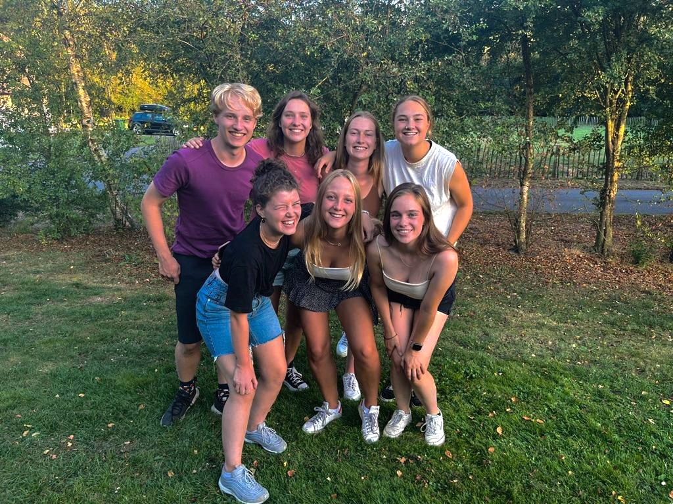
Below we introduce you to the board of the 2021/2022 season. If you have seen a nice committee just above, do not hesitate to send the corresponding board member a message!

President
Renee de Groot
06-37307095
voorzitter@antibarbari.nl

Secretary
Guus de Bruin
06-44286113
secretaris@antibarbari.nl

For:
- Questions about matches (forms, referees, membership)
- Questions about your membership
- Changes in personal information (address, telephone number, e-mail)

Vice President
Iris de Winter
06-38610381
vicevoorzitter@antibarbari.nl
Iris is your contact person within the board.

She leads the following committees:
- Cook committee
- Skitrip committee
- First year committee
- Lustrum trip committee

Technical Commissioner
Iris Mulder
06-29819185
technisch@antibarbari.nl

Iris is available for questions about:
- Materials
- Clothing for games

She leads the following committees:
- Tournament committee
- ABB Open Committee
- Technical Committees

Treasurer
Evi de Vriend
06-37441602
penningmeester@antibarbari.nl

For:
- Questions about contribution.

Internal Commissioner
Rosa Verkerk
06-15608912
intern@antibarbari.nl

She leads the following committee:
- Party committee

Commissioner Marketing
Faye van Meelen
06-30248415
marketing@antibarbari.nl

She leads the following committees:
- Insta Committee
- Antiblablablad Committee
- Eurekaweek Committee

7.b. Contact person
Should you encounter a situation within the team, the association or in your home situation during the season and you feel the need to share this with someone within our association, you can send a message to contactpersoon@antibarbari.nl. They will listen to your situation and if necessary, they will work with you to find a solution!

7.c. Code of conduct
Code of Conduct R.S.V. Antibarbari
Dear Reader,
This is the code of conduct for the Rotterdam Student Football Association Antibarbari. This document contains the rules of conduct that all members, trainers and other staff must adhere to. This code of conduct was presented for approval to the ALV on August 27, 2021 and approved.
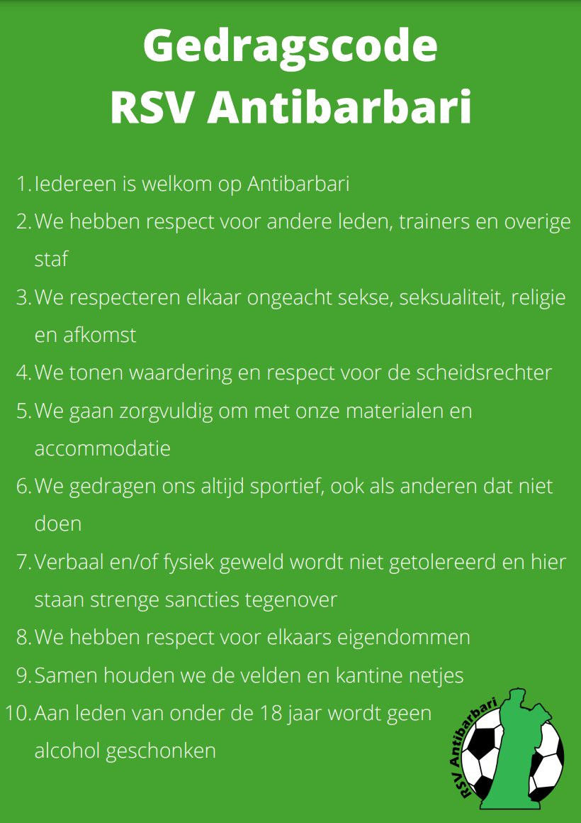
Last modified: August 31, 2021

Goal
At Antibarbari, we want everyone to feel comfortable and safe and to enjoy playing football regardless of gender, sexuality, origin, religion, skin colour, or anything else that is part of our unique identity. This code of conduct illustrates the norms and values that we safeguard at Antibarbari.
To ensure that everyone feels at home in our association, the rules of conduct must be observed by everyone. When a member or trainer does not comply, the board of RSV Antibarbari will address him / her. Violation of the rules may also result in sanctions.
Let's work together to ensure that Antibarbari remains a nice and above all cosy club, where everyone can be themselves.
Antibarbari Code of Conduct
Respect
- Everyone is welcome at Antibarbari
- We respect other members, trainers and other staff.
- We respect each other regardless of sex, sexuality, religion and origin.
- We show appreciation and respect for the referee.
- We have respect for each other's property
Responsibility
- We treat our materials and accommodation with care
- Together we keep the fields and canteen tidy
- No alcohol will be served to members under the age of 18
- If someone does not comply with the code of conduct, we will address that person
Sportsmanship
- We always behave in a sportive way, even if others do not
- Verbal and physical violence will not be tolerated and will be met with severe penalties

